Strengthening TA-Level Accessibility and Spatial Equity in GBV Service Provision in Mzimba District

Purpose and Scope
Mzimba District hosts one of the largest rural populations in Malawi and remains a high-burden district for gender-based violence (GBV). Despite comparatively strong service availability especially along the central north–south transport corridor survivors in upland and off-corridor areas face substantial physical, terrain-related, and economic barriers in accessing police, health, psychosocial and justice services.
Spatial analysis shows that most GBV services in TAs M’Mbelwa and Chindi cluster along the main valley road, while extensive upland zones remain weakly served. Average travel times are moderate (30–45 minutes), but steep elevation gradients and poor roads create significant inequities within the district. These patterns directly influence help-seeking, referral follow-through, and court progression.
This policy brief provides a synthesis of GIS spatial analysis, TA-level population density mapping and facility-level referral and resolution data and actionable recommendations for improving survivor-centred access and reducing spatial inequity in Mzimba.

Spatial Profile of GBV Services in Mzimba
Mzimba shows moderate population density overall (100–161 persons/km² in the mapped zones), but both mapped TAs contain heterogeneous demographic pockets:
- Mzimba had 22 mapped GBV service points, all located in TA Chindi (9 facilities) and TA M’Mbelwa (13 facilities). Together, these form one of the most service-dense GBV corridors in the study.
- In M’Mbelwa, the 13 service points comprised 7 Community Victim Units (CVUs), 1 health clinic, 3 One Stop Centre–type facilities, 1 Police Victim Support Unit (PVSU) and 1 women’s forum, creating a relatively rich mix of community, health, police and integrated services along the main north–south road and river.
- In Chindi, the 9 facilities include a similar blend of health clinics, PVSUs, CVUs and other community structures concentrated along the primary east–west and north–south road axes, reinforcing its role as a high-capacity GBV hub for the district.
- However, both maps show that this provider mix is heavily corridor-bound: upland and off-road communities sit at the edges of these service clusters and face significantly longer travel distances and higher costs to access the same range of GBV services.
- M’Mbelwa contains both moderately dense settlement clusters and lower-density outer zones.
This corresponds with the linear service corridor seen in maps dense populations align with the main road, while sparsely populated uplands and forested areas remain underserved.
- Chindi also occupies the 100–136 persons/km² band, but its density is concentrated around the central transport spine, explaining its high caseload and the strong demand for nearby PVSU and clinic services.
- Average travel time to the nearest GBV service in M’Mbelwa sits in the 30–60 minute band, while in Chindi it is typically 20–40 minutes, with shorter journeys for communities near the primary road network. However, upland and off-corridor settlements in both TAs face significantly longer and more variable travel times, especially during the rainy season when roads deteriorate.
- These spatial gaps mean that Mzimba’s apparently good coverage is uneven at TA level: survivors living in upland villages face longer walks, steeper terrain and higher transport costs, which likely suppress reporting and reduce follow-through to police and courts.
- Combined with above-median transport costs (roughly MWK 8,000–12,000 per trip for many M’Mbelwa and Chindi-origin survivors), this pattern means that, although Mzimba functions as a high-capacity GBV hub, effective access is strongly corridor-biased, and poorer households in remote hills still struggle to reach the same level of support.
Implication:
Mzimba TAs generate high GBV caseloads because population density is moderate-to-high where services exist. Low-density outlying areas, however, contribute substantially to distance- and terrain-related access gaps.
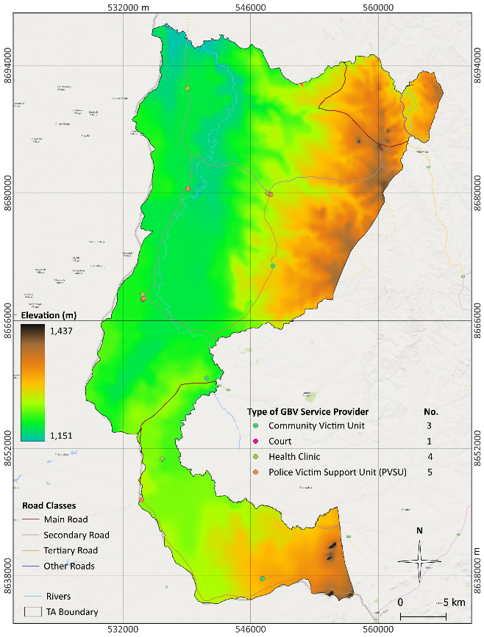
Figure 1: Distribution of GBV Service Providers in TA M'mberwa
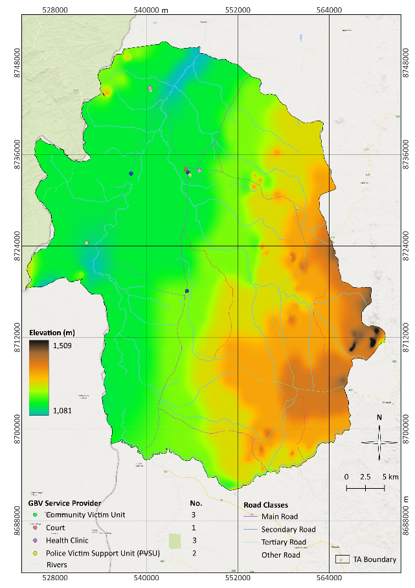
Figure 2: Distribution of GBV Service Providers in TA Chindi

Key Accessibility Gaps and Systems Challenges
The combined spatial, referral and case-management data points to a GBV system that is present and active across the two TAs, but structurally uneven, costly to access, and weakest where survivors need it most at the level of justice and long-term protection. Five interlinked systems challenges stand out.
- Spatial inequity across and within TAs was pronounced, with GBV services concentrated in a small number of service providers while large peripheral areas remained underserved, resulting in access-driven under-reporting rather than true differences in GBV incidence.
- Long travel distances (25–35 km), extended travel times (30–40 minutes), and high transport costs (MWK 8,000–12,000 per trip) acted as structural filters that disproportionately excluded poor, rural and remote survivors particularly in far-remote locations from accessing GBV services.
- While counselling and basic support were widely available, specialised GBV services including forensic care, legal aid and OSCs were sparse and district-based, and the justice system remained the weakest link, with magistrate courts resolving only 25% of cases and lacking criminal jurisdiction at 2nd/3rd grade magistrate level.
- Referral chains exhibited a steep attrition curve, where most cases originated and were resolved at community, health and police levels, but survivor engagement dropped sharply as cases moved toward the justice system due to distance, repeated travel requirements, costs and weak feedback loops.
- GBV information systems were fragmented across paper and digital tools, lacked unique case identifiers, applied inconsistent definitions of “case” and “resolved,” and suffered from missing disaggregation, resulting in unreliable totals, untraceable survivor pathways and limited capacity for accountability or learning.
- Survivor outcomes were shaped by interconnected location constraints determining physical access, income determining ability to follow through, service type determining case trajectory, and weak data systems obscuring gaps, highlighting the need for simultaneous action on spatial equity, affordability, service depth, referral linkages and data integration.
- Even before considering communication, attitudinal or financial barriers, around one in three GBV service points explicitly reported that their physical infrastructure is not accessible to persons with disabilities, and only about half reported meeting basic accessibility standards (e.g. ramps, wide entrances, accessible toilets).

Policy Recommendations
Policy Option 1: Support Circuit or Mobile Court Sessions, Mobile Legal Clinics Mobile
Support circuit or mobile court sessions in high-burden, distant TAs to reduce the number of long, costly trips required for survivors and witnesses.
Strengthen police–prosecution–court communication and case tracking so that criminal GBV matters referred out of TAs are systematically followed through at district level.
This option directly addresses spatial exclusion and provides timely services closer to survivors’ homes.
Advantages: Immediate reduction in travel burdens; improved early reporting; higher likelihood of referral completion.
Feasibility & Cost: Moderate, with strong donor feasibility.
Equity Impacts: High—prioritises remote, low-income and terrain-isolated households.
Policy Option 2: Establish a Sustainable Survivor Support Fund (SSF) and Accompaniment Mechanism
Establish targeted SSF schemes triggered for TAs beyond 20–30 km from key services, to reduce cost- and distance-related exclusion—particularly for survivors from upland and off-corridor settlements in M’Mbelwa and Chindi. Mzimba District should establish a sustainable, district-level SSF. The SSF would provide targeted emergency transport, short-stay support and safe accompaniment for survivors needing to reach health, police or court services. Sustainability would be achieved through a hybrid financing model combining a district budget line, partner seed funding, CSR partnerships with local businesses, and proceeds from community income-generating initiatives managed by women’s groups or CVSUs. Voucher-based transport agreements with local motorcycle and minibus operators would control costs and ensure predictability. Embedded within district GBV coordination, the SSF would enable survivors in remote upland villages to complete referrals and justice processes that would otherwise be financially impossible.

Advantages: Reduces financial barriers; increases court case follow-through.
Equity: High positive impact on the poorest households.
Policy Option 3: Co-design upgrading of Corridor-Based High-Volume Facilities
Facilities along the main Mzimba transport corridor manage large caseloads. Strengthening their counselling spaces, privacy infrastructure, and medico-legal documentation capacity would reduce unnecessary referrals and improve service quality.
Co-design upgrades with Organisations of Persons with Disabilities (OPDs) at district level to test access routes, advise on practical modifications, and validate whether reported “Yes” responses on accessibility reflect real, user-experienced access, not just provider perception.
Set minimum accessibility standards or a basic package for GBV service points (ramp or gently sloped entrance, firm pathways, accessible latrine, clear signage) that all GBV service providers should progressively meet.
Advantages: Builds on existing strong hubs; improves efficiency and quality.
Feasibility: High.
Equity: Benefits densely populated areas.
Policy Option 4: Institutionalising GIS for Planning and Resource Allocation
Annual GIS-based audits of service coverage, population density, travel times and TA-level gaps would inform district GBV planning and budgeting.
Advantages: Enhances evidence-based prioritisation; prevents spatial neglect.
Feasibility: High with partner support.

Methodology
Policy options were derived from spatial accessibility modelling (travel time surfaces, road networks, elevation) and TA-level population density analysis. Facility-level referral and resolution data (2022–2025) were triangulated with key informant consultations with police, health workers, CVUs, and district officers. Evidence quality was assessed through data completeness checks and plausibility reviews.

Further Important Considerations
Because of data-quality limitations (inconsistent definitions, outliers, missing values), the figures in this study were best treated as operational estimates rather than precise surveillance statistics. This implied that the rollout of recommendations should be coupled with an explicit monitoring and learning agenda: annual updates to GIS layers and dashboards, routine data-quality checks, and periodic sense-making sessions at district level to review patterns (e.g. travel times, referral completion, court progression) and adjust interventions accordingly. Over time, this iterative use of data could be more transformative than any single investment in infrastructure or training.

Acknowledgements
Prepared in collaboration with the Mzimba District Gender Office, Social Welfare Office, Health Office, MICGBV partners, and frontline GBV service providers.

